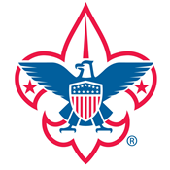
Palmetto Council
York District

HOWARD HUNTER AWARD
2016-2017 Youth Award

To earn the award, a Scout must complete all of the requirements listed. The 2017 award year starts on November 1, 2016, and ends October 31, 2017.
- Attend Beach Sweep or 2 nights of fall camping with your unit
- Attend a winter troop campout or Polar Bear
- Attend Summer Camp (minimum 6 nights)
- Minimum 12 nights camping with your unit (including district campouts & summer camp)
- Unit Service (must be approved by the Troop Committee) or Conservation Project (At a Palmetto Council Camp). Minimum 6 hours.
The Scoutmaster will verify the completion of the award requirements and the eligibility for the award prior to submitting the Scout’s name. Please submit the Scout’s name, rank, and year to be awarded.
Name:____________________________________________________________________
Rank:____________________________________________________________________
Year (Number of years receiving award):________________________________________

Name of recipients must be submitted to Joshua Bouldin (Joshua.bouldin@scouting.org) by December 21, 2017.

