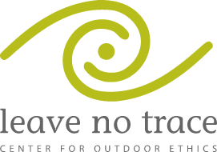
T.O.T.A.L. Training Weekend
Camp Bob Hardin May 2-4th

Leave No Trace Trainer Course
LEAVE NO TRACE REGISTRATION FORM | COURSE NUMBER  SC-BSA-LNTT-52014-01
First Name:
Last Name:
Email:
Home Phone:
Cell Phone:
Mailing Address:
City:
State:
Zip Code:
BSA INFORMATION
Council:
District:
Unit:
Role (Scout, SM,…):
Any Allergies?
(if so, please list)
This event is a nationally certified Leave No Trace Trainer course organized through the BSA and the Leave No Trace Center for Outdoor Ethics (www.lnt.org ). Participants will spend 16 hours in a frontcountry setting, focused on how to practice Leave No Trace skills and effectively train others.
Registration due to the office by Friday, April 18. 2014. Space is limited to 14 and slots are filled on a first come, first served basis, based on when the following forms are received at the Council Office:

1. Registration 420 South Church Street
2. Payment ($45) Spartanburg, SC 29306
3. LNT Trainer Course Release 864-585-4391

Current BSA Health Forms (A&B) will need to be turned in at Check-In on Friday May 2, 2013.

