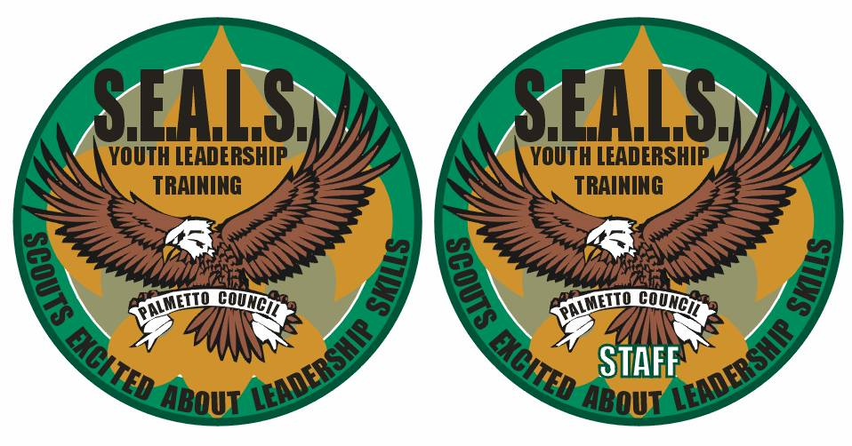**S.E.A.L.S.  
SCOUTS EXCITED ABOUT LEADERSHIP SKILLS**

**Camp Bob Hardin: May 1 – 3, 2015**

**What is it:**This Junior Leadership Training Course is for CURRENT, or soon to be leaders in your troop who are 14 and younger, with a minimum rank of Tenderfoot or above, any exceptions must be approved by the course director. Participants will be shown how to apply and use leadership skills and Scout spirit effectively in a boy lead troop in their specific leadership position. All scouts attending must be recommended by their scoutmaster. **Participants are required to have completed I.L.S.T. or T.L.T. (Troop Leadership Training) within their home troop in the last 12 months before attending S.E.A.L.S.**

**A mandatory scoutmaster meeting is held on Friday Night from 7:30 – 8:30pm.**

**What can you expect:**Participants will be divided into patrols of eight members. A total of 48 spots are available so you will need to register early. If registration exceeds 48, a waiting list will be created. Each patrol member will be provided with more information after registering. A website will be available shortly that will have more information about the course including what you will need to bring. Participants will have an opportunity to earn a S.E.A.L.S. strip that can be worn on their uniform. You will also receive other S.E.A.L.S. gear and have the opportunity to purchase a S.E.A.L.S. T-Shirt.

**When and where:** The event will be held May 1- 3, 2015 at Camp Bob Hardin. Check-in will begin at 6:30 p.m. on Friday, May 1 and the course will finish with a graduation ceremony starting at 10:30am on Sunday, May 3 in the dining hall.

**To accommodate as many troops as possible, each Troop Scoutmaster can submit 2 youth for this course, as well as 2 alternates. If the course is not full two weeks before the course start date, then alternates will be used to fill the course. All registrations will be due no later than Friday, April 17th.**

**Cost: $50.00 per participant. Includes materials, meals and S.E.A.L.S. Gear**

**Equipment lists and detailed instructions for arrival are posted on the S.E.A.L.S. website (**[**http://sites.google.com/site/pcsealscourse**](http://sites.google.com/site/pcsealscourse)**)   
and will be sent to Scoutmasters upon their unit’s registration at the Council Office.**

**If you have any questions, e-mail Robert Mercer, S.E.A.L.S. Course Director, at** roblmercer3@gmail.com.

**Current BSA Health Forms will need to be brought with each participant and turned in at Check-In on Friday, May 1st.**

**Registration information is on the back of this form. Please return the form to the Council Office:**

**Palmetto Council  
420 South Church Street  
Spartanburg, SC 29306  
864-585-4391**



**S.E.A.L.S.  
SCOUTS EXCITED ABOUT LEADERSHIP SKILLS  
May 1 – May 3, 2015**

**Scoutmaster** (please print or type) -- Date:

Name Troop# District

Address, City, State, Zip

Email Address Phone#

Patrol Leaders, Troop Guides and Troop Quartermasters  
Please clearly print all requested information (Names will be printed on the course certificates as they appear here)

1. Age **Rank** Food Allergies? Y or N Please explain  
 Address: I.L.S.T. /Troop Leadership Training: Attended on: _______

E-mail: Phone: T-Shirt Size(adult) (S, M, L, XL

2. Age **Rank** Food Allergies? Y or N Please explain

Address: I.L.S.T. /Troop Leadership Training: Attended on: _______

E-mail:_____________________________ __ Phone: ______________________T-Shirt Size(adult) (S, M, L, XL)

**Alternate(s)**

1. Age **Rank** Food Allergies? Y or N Please explain

Address: I.L.S.T /Troop Leadership Training: Attended on: _______

E-mail:________________________________ Phone: ______________________T-Shirt Size(adult) (S, M, L, XL)

2. Age **Rank** Food Allergies? Y or N Please explain

Address: I.L.S.T. /Troop Leadership Training: Attended on: _______

E-mail: ________________________________ Phone: _____________________T-Shirt Size(adult) (S, M, L, XL)

Registration for the Troop should be made by the Scoutmaster.  
All attendees must have approval (above) of their Scoutmaster.

If there are any medical conditions that need to be monitored, please notify the S.E.A.L.S. Course Director  
and provide a detailed description of these conditions.

**Scoutmaster Approval Signature Date:**

**Space is limited and slots are filled on a first come, first served basis, based on when the following forms are received   
at the Council Office:**

1. **Registration** **420 South Church Street**
2. **Payment** **Spartanburg, SC 29306**
3. **Code of Conduct**  **864-585-4391**

**Current BSA Health Forms will need to be turned in at Check-In on Friday May 1, 2015.**

**S.E.A.L.S.**

Intermediate Youth Leader Training

Palmetto Council, Boy Scouts of America  
https://sites.google.com/site/pcsealscourse

**Scouts participating in S.E.A.L.S. must agree to abide by the Scout Oath, Scout Law, the S.E.A.L.S. Statement of Understanding and Code of Conduct.**

**Scout Oath**

On my honor I will do my best

To do my duty to God and my country

and to obey the Scout Law;

To help other people at all times;

To keep myself physically strong,   
mentally awake, and morally straight.

**Statement of Understanding**

All S.E.A.L.S. course participants are selected to represent their local troops and councils based on their qualifications in character, camping skills, physical and personal fitness, and leadership qualities. S.E.A.L.S. course participants and their parents or guardians must read this Code of Conduct and Statement of Understanding, and the Scout must agree to abide by them as a condition of participation. Ultimately, each participant must be responsible for his own behavior, and any serious misconduct or infraction of rules and regulations may result in expulsion from the S.E.A.L.S. Course.

**Code of Conduct**

**1.** The Scout Oath and Law will be my guide throughout the S.E.A.L.S. course. I agree to obey the safety rules and instructions of all staff members.

**2.** I understand that S.E.A.L.S. adult leaders are responsible for the supervision of all staff and participants, and will maintain discipline, security, safety and adherence to the S.E.A.L.S. course Code of Conduct. I understand that all S.E.A.L.S. adult leaders will abide by the Scout Oath and Law and all U.S., state and local laws.

**3.** I will label all my personal items and leave valuable items at home. Neither S.E.A.L.S. course staff nor the BSA camp staff will be responsible for loss, breakage, or theft of personal items.

**4.** I will set a good example by keeping myself neatly

dressed and presentable in the proper S.E.A.L.S. course uniform.

**5.** I will attend and participate in all scheduled programs

and will cooperate with other S.E.A.L.S. course participants.

**6.** In consideration for other participants, I agree to follow the bedtime and sleep schedule of the course.

**7.** I will be responsible for keeping my tent and personal gear labeled, clean and neat. I will do my share to prevent littering of the BSA camp we are using.

**Scout Law**

Trustworthy Obedient

Loyal Cheerful

Helpful Thrifty

Friendly Brave

Courteous Clean

Kind Reverent

**8.** I will demonstrate respect for S.E.A.L.S. course and BSA camp property and be personally responsible for any loss, breakage, or vandalism of property as a result of my actions.

**9.** I understand that the following behaviors are expressly forbidden and will be grounds for my immediate expulsion from S.E.A.L.S.:

• purchase, possession, or consumption of alcoholic

beverages

• purchase, possession, or consumption of illegal drugs

• possession or use of firearms or dangerous weapons

• possession or detonation of fireworks

• theft

• intentionally threatening or injuring others

• intentionally damaging property

**10.** I understand that serious and/or repetitive personal behavior violations, including use of tobacco, cheating, stealing, possession of lasers of any type, gambling, dishonesty, swearing, fighting, cursing, hazing or any action which fails to show respect for an individual will result in my expulsion from the S.E.A.L.S. course.

**11.** I understand that serious violations of this code may

result in expulsion from the S.E.A.L.S. course at my own expense. There are no refunds of course fees. All decisions by the Course Director are final.

Scout Signed: ______________________ Date: _______

**Scout Name**: _______________________**Troop**: _____

Parent Signed: ______________________ Date: ______

**Parent Name**: ________________________________

**Parent Primary Phone: ________________________   
(24 Hour Availability)**

**Parent Alternate Phone: _______________________**