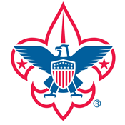
Palmetto Council
York District

HOWARD HUNTER AWARD
2016-2017 Adult Award

To earn the award, a Scouter must complete all of the requirements listed. The 2017 award year starts on November 1, 2016, and ends October 31, 2017.
- Must complete indoor & outdoor training
- Must have current Youth Protection training.
- Long term camping or training (4 nights)
- Minimum 12 nights camping with your unit to date
- Unit Service (must be approved by the Troop Committee) or Conservation Project (At a Palmetto Council Camp). Minimum 6 hours.
- You must attend 2 campouts from the below list
  - Fall Camporee
  - Polar Bear or a winter campout with your unit
  - Beach Sweep
The Scoutmaster will verify the completion of the award requirements and the eligibility for the award prior to submitting the Scouter’s name. Please submit the Scouter’s name, position, and year to be awarded.
Name:____________________________________________________________________
Position:__________________________________________________________________
Year (Number of years receiving award):________________________________________
Name of recipients must be submitted to Joshua Bouldin (Joshua.bouldin@scouting.org) by December 21, 2017.

