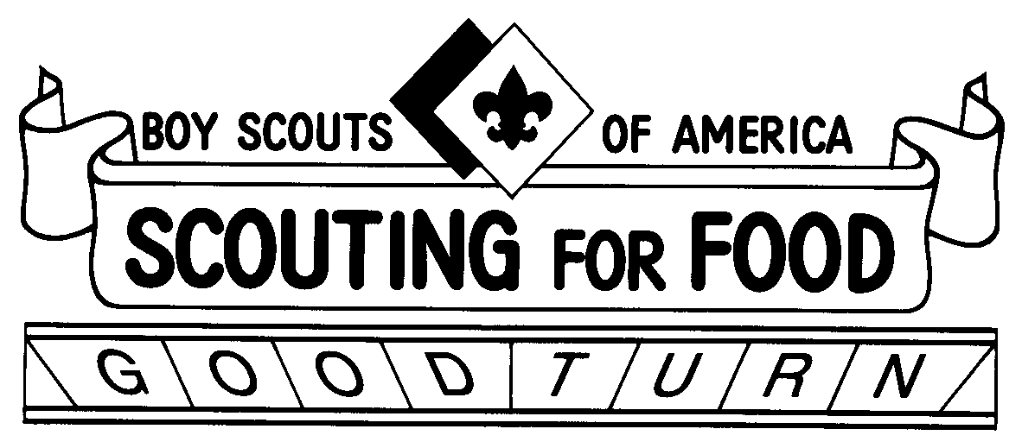
ease help the Palmetto Council Boy Scouts of America make a difference by donating non-perishable food items, personal hygiene products, or baby food & diapers. We are also collecting new and gently used coats. All donations go directly to local Food Banks, Shelters and Soup Kitchens.
We will be back on November 10th to pick up your donations, so please place this bag on your front door step on Friday night or Saturday morning by 9am so the scouts can pick it up. If you have a dog outside, please leave the bag at the end of your driveway.
If you miss our Scouts or are unavailable on the 10th you can drop off your donation at one of the locations below until November 10th or visit our website for a list of local food banks.
Troop/Pack/Crew Coordinator @ 803-XXX-XXXX www.palmettocouncil.org
Thank you for your support!

Please help the Palmetto Council Boy Scouts of America make a difference by donating non-perishable food items, personal hygiene products, or baby food & diapers. We are also collecting new and gently used coats. All donations go directly to local Food Banks, Shelters and Soup Kitchens.
We will be back on November 10th to pick up your donations, so please place this bag on your front door step on Friday night or Saturday morning by 9am so the scouts can pick it up. If you have a dog outside, please leave the bag at the end of your driveway.
If you miss our Scouts or are unavailable on the 10th you can drop off your donation at one of the locations below until November 10th or visit our website for a list of local food banks.
Troop/Pack/ Crew Coordinator @ 803-XXX-XXXX www.palmettocouncil.org
Thank you for your support!

