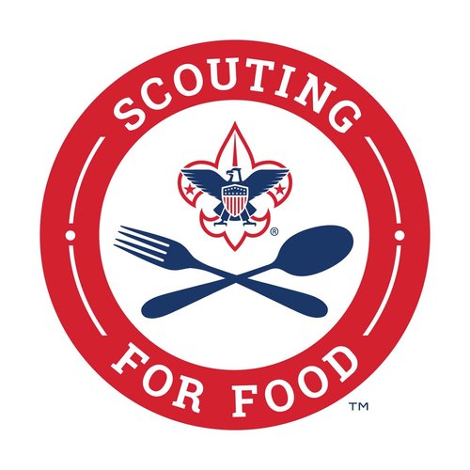
Please help Scout (Unit type/number) make a difference by donating non-perishable food items during the annual 2024 Scouting for Food drive. All donations go directly to (insert local food bank).
We will be back on (date) to pick up your donations, so please bring your donations back to church on (date).
If you miss our Scouts or are unavailable on (date) you can drop off your donation at (insert local food bank) or make a monetary gift to a local pantry by scanning the QR code below. Thank you in advance for your support of those in need in our community!

