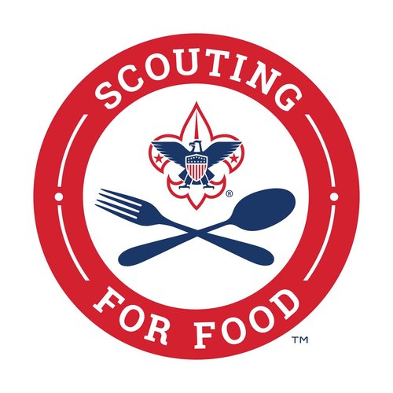
Please help Scout (unit type/number) make a difference by donating non-perishable food items during our annual 2024 Scouting for Food drive. All donations go directly to (insert food bank).
When shopping today, please consider purchasing the below items which the Scouts will deliver to (insert food bank). You can leave the purchased items with us when you exit the store today and we will deliver them for you.
Requested Items:
• Item 1 Item 4 Item 7
• Item 2 Item 5 Item 8

